**GIT-2**

Implement git ignore command to ignore unwanted files and folders

Step1: Going to my Git Working Directory



Step2: Creating a .log File and log Folder

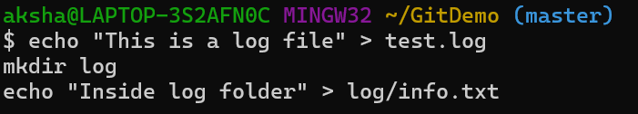

Step3: Creating .gitignore File and adding log commands

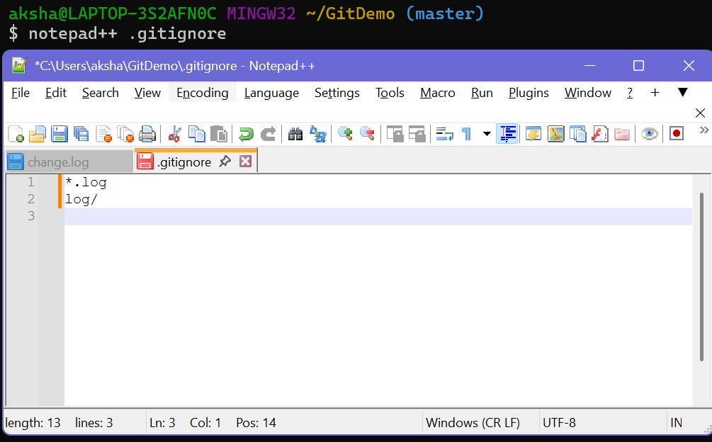

Step4: Checking Git Status

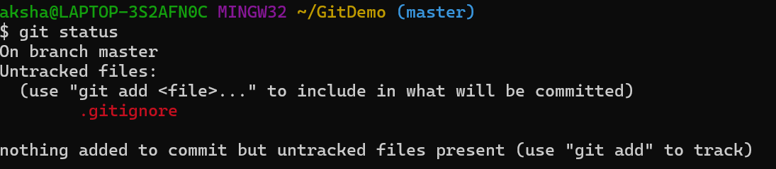

Step5: Staging and Commiting .gitignore

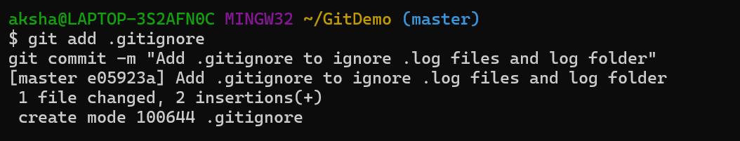

Step6: Pushing to Remote Repository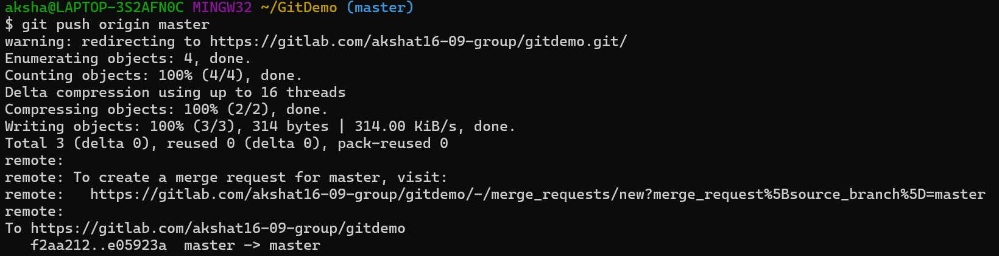

Final Verification

